
TOPIC: INTERNET PROGRAMMING
NAME: JUAKIM NJUGUNA
ADM NO: BSCCS/2024/54733
COURSE: BACHELOR OF SCIENCE IN COMPUTER SCIENCE
UNIT CODE: BIT3208
UNIT NAME: ADVANCED WEB DEVELOPMENT
DEPARTMENT: COMPUTING AND INFORMATICS
ACADEMIC YEAR:3.2
LECTURER: NYORO
SUBMISSION DATE:
PROJECT DETAILS:
PROJECT TITLE:
GITHUB REPOSITORY:
WEBSITE LINK:

Contents
1.0 WEEK 1-3 1
1.2 WEEK 3 Java script and php basics 4
3.1 DATABASE CREATION 7

Figure 1 Control panel 2
Figure 2 Operation on local host 3
Figure 3 Canva layout 3
Figure 4 Java script validation 4
Figure 5 Password strength checker 5
Figure 6 Login page 6
Figure 7 mySQL database creation 7
Figure 8 Database connection string 7
Figure 9 Database tables 8

WEEK 1-3

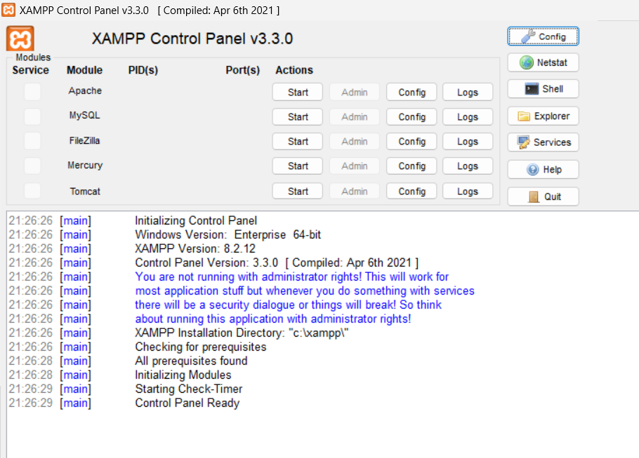
Figure 1 Control panel
The image shows a successfully installed xampp running in the control panel

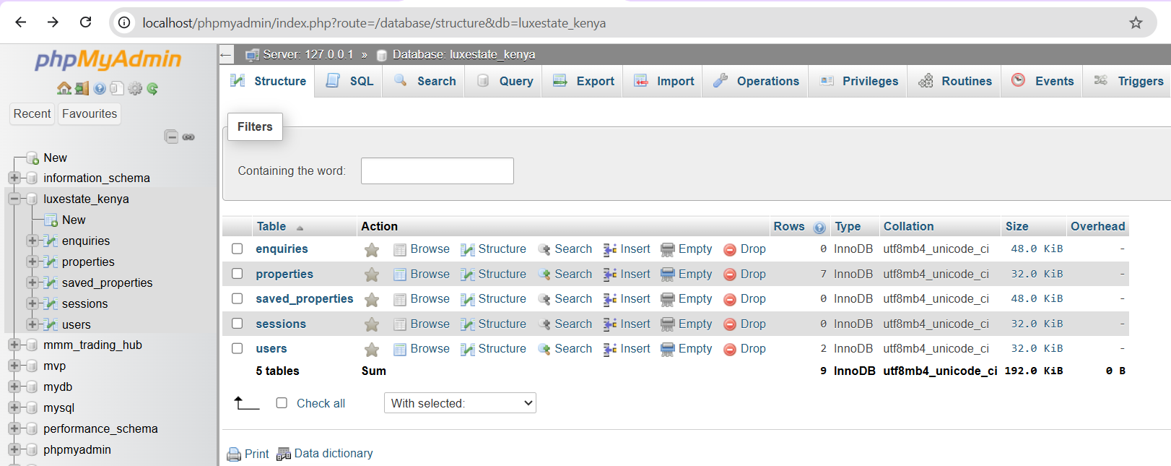
Figure 2 Operation on local host

1.1 WEEK 2
I used canva templates for a simple layout of the web design I wanted for the real estate company.
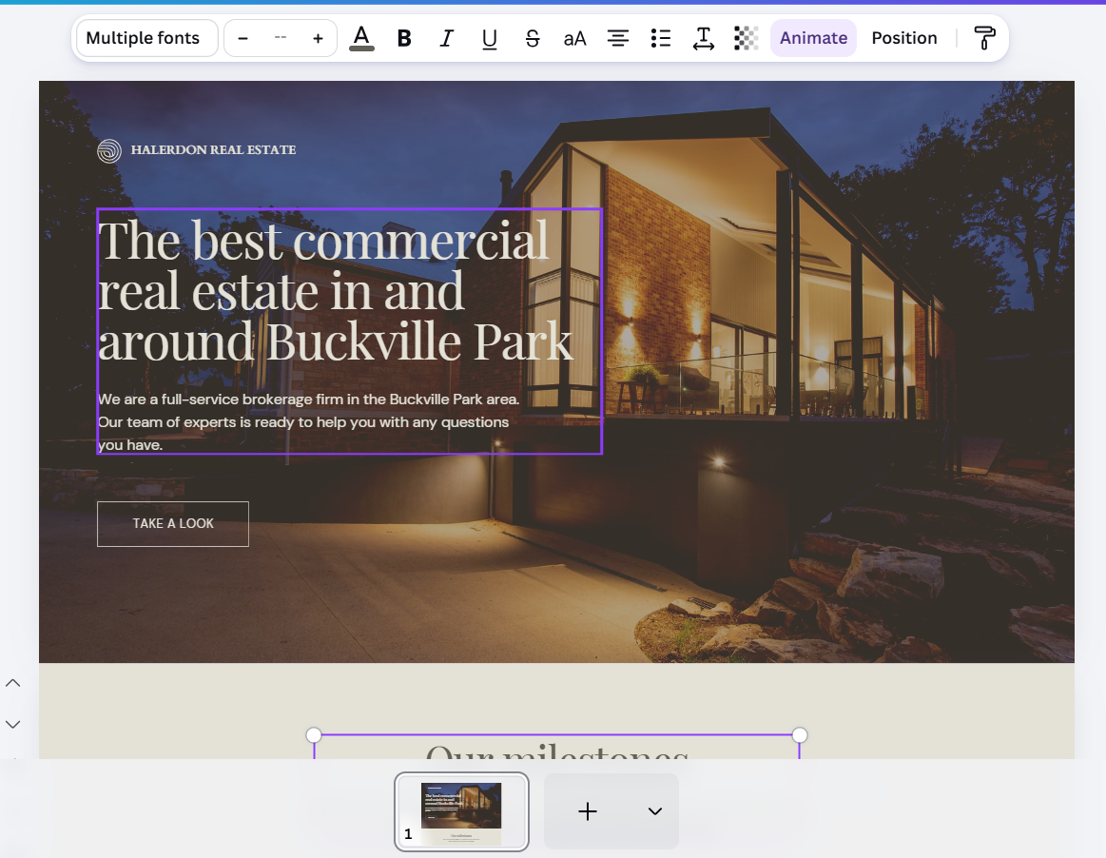
Figure 3 Canva layout

1.2 WEEK 3 Java script and php basics
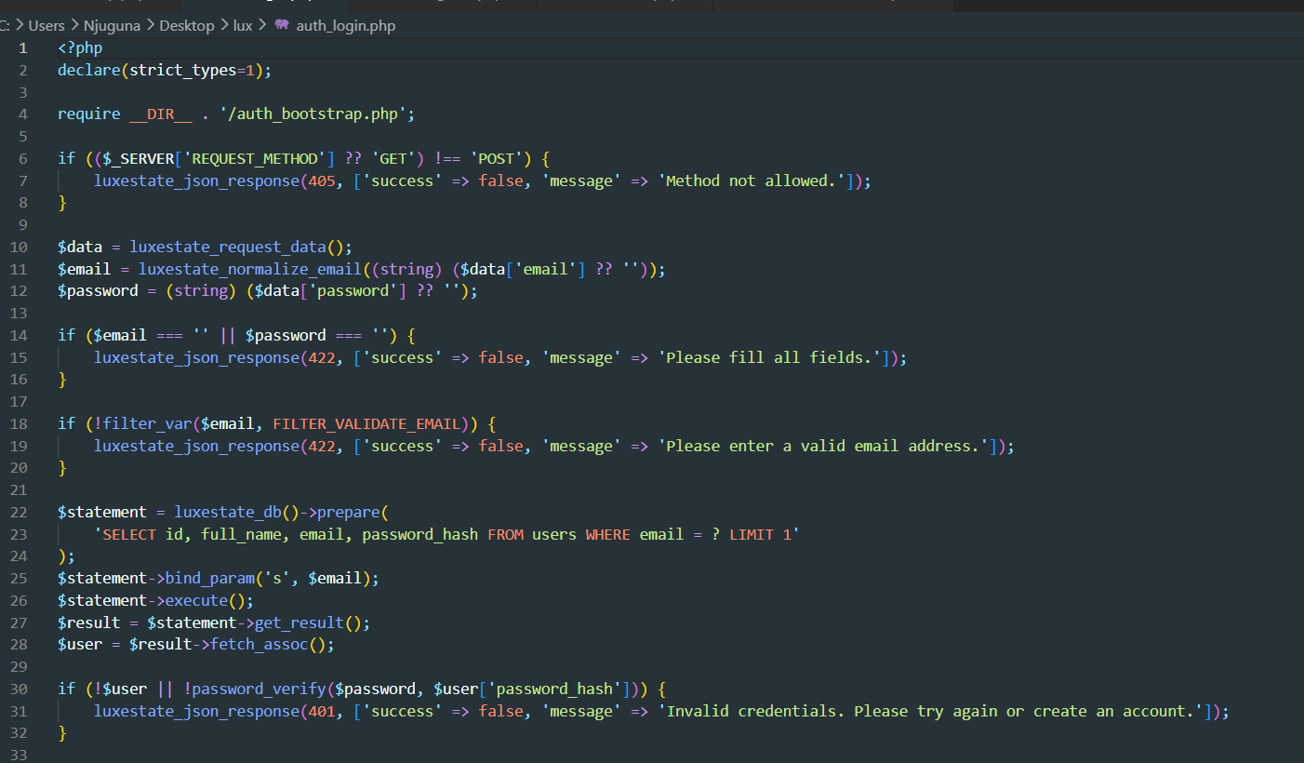
Figure 4 Java script validation
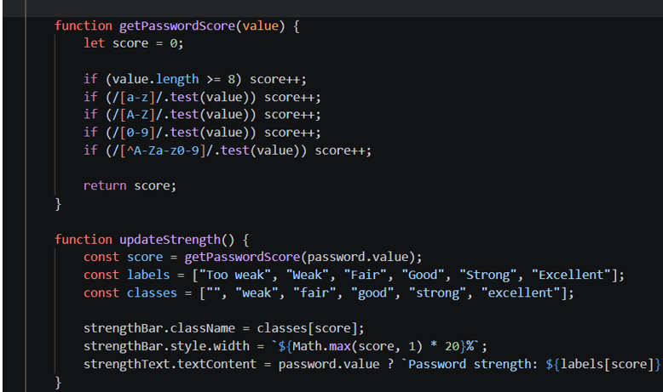
Figure 5 Password strength checker

2.1 WEEK 4 SIMPLE PHP CONCEPTS

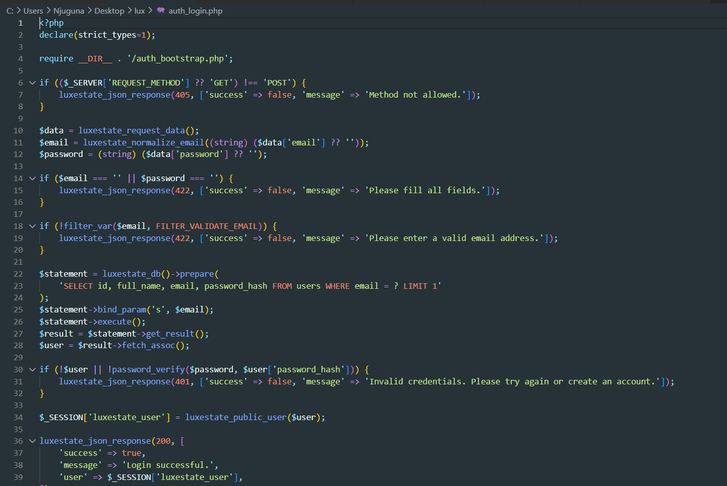
Figure 6 Login form
The login form contains a depiction of the entire website and what the user expects once details are verified.
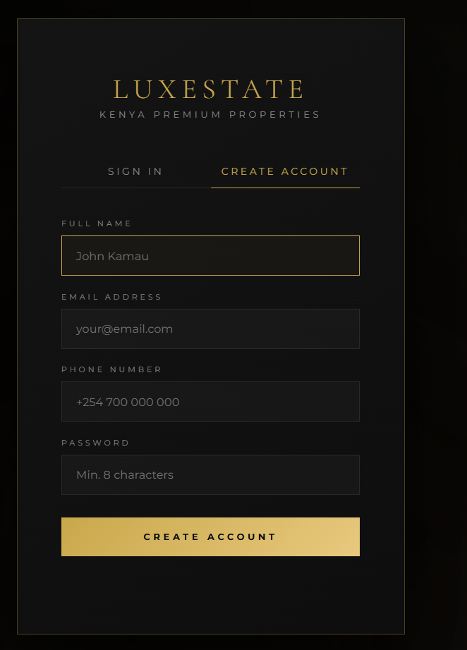
Figure 7 Login page

3.1 DATABASE CREATION
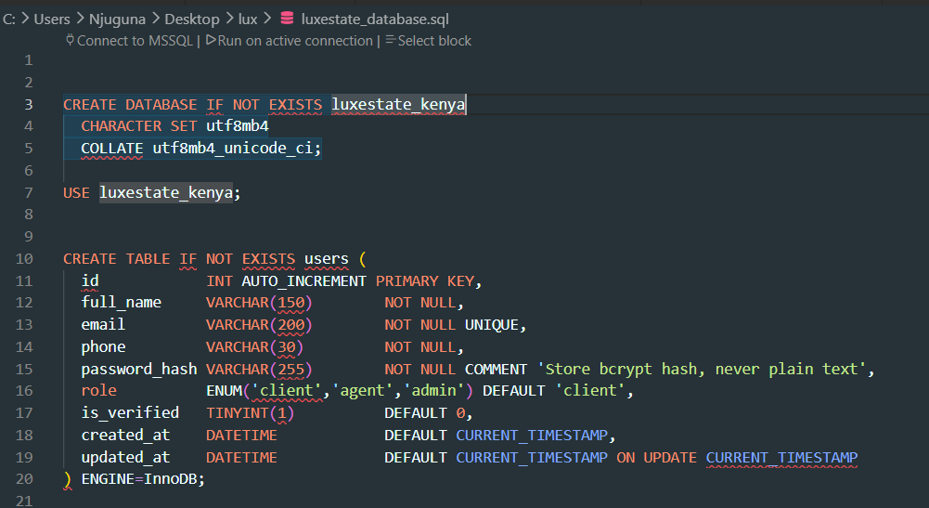
Figure 8 mySQL database creation
mySQL database creation – followed with the connection string below

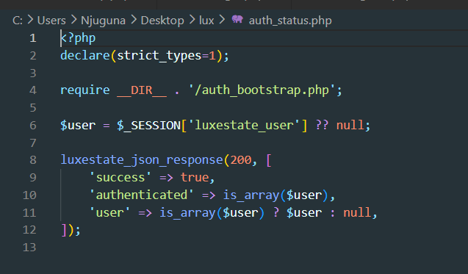
Figure 9 Database connection string
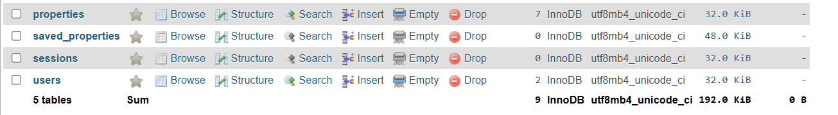
Figure 10 Database tables

